|  |
| --- |
| Department of Software Engineering  Mehran University of Engineering and Technology, Jamshoro |

|  |  |  |  |
| --- | --- | --- | --- |
| SWE411 – SOFTWARE DESIGN AND ARCHITECTURE | | | |
| Instructor | Mr. Arsalan Aftab Memon | **Practical/Lab No.** | 03 |
| Date |  | **CLOs** | 3 |
| Signature |  | **Assessment Score** | 0.4 Marks |

|  |  |
| --- | --- |
| Topic |  |
| Objectives | * Interaction diagrams |

|  |
| --- |
| Lab Discussion: Theoretical concepts and Procedural steps |

**Tool: - STAR UML**

**Theory:**

**Interaction diagrams**

Interaction diagrams are used to describe some type of interactions among the different elements in the model. So this interaction is a part of dynamic behavior of the system. This interactive behavior is represented in UML by two diagrams known as Sequence *diagram* and *Collaboration diagram*. The basic purposes of both the diagrams are similar. Sequence diagram emphasizes on time sequence of messages and collaboration diagram emphasizes on the structural organization of the objects that send and receive messages.

**What is needed for interaction diagram?**

The following things are to be identified clearly before drawing the interaction diagram:

* Objects taking part in the interaction.
* Message flows among the objects.
* The sequence in which the messages are flowing.
* Object organization.

**SEQUENCE DIAGRAM**

The Sequence Diagram models the collaboration of objects based on a time sequence. It depicts the objects and classes involved in the scenario and the sequence of messages exchanged between the objects needed to carry out the functionality of the scenario. Sequence diagrams are typically associated with use case realizations in the Logical View of the system under development.

**NOTATION**

A sequence diagram shows, as parallel vertical lines (*lifelines*), different processes or objects that live simultaneously, and, as horizontal arrows, the messages exchanged between them, in the order in which they occur. This allows the specification of simple runtime scenarios in a graphical manner.

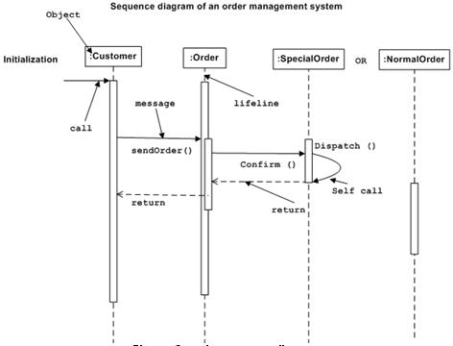

**COLLABORATION DIAGRAM**

The second interaction diagram is collaboration diagram. It shows the object organization as shown below. Here in collaboration diagram the method call sequence is indicated by some numbering technique as shown below. The number indicates how the methods are called one after another. The method calls are similar to that of a sequence diagram. But the difference is that the sequence diagram does not describe the object organization where as the collaboration diagram shows the object organization.

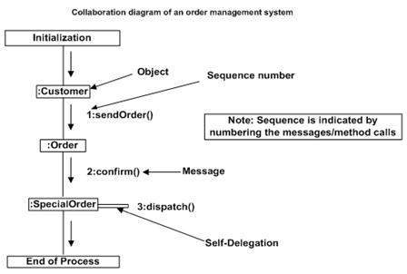

**PURPOSE OF INTERACTION DIAGRAMS**

* To capture dynamic behavior of a system.
* To describe the message flow in the system.
* To describe structural organization of the objects.
* To describe interaction among objects.

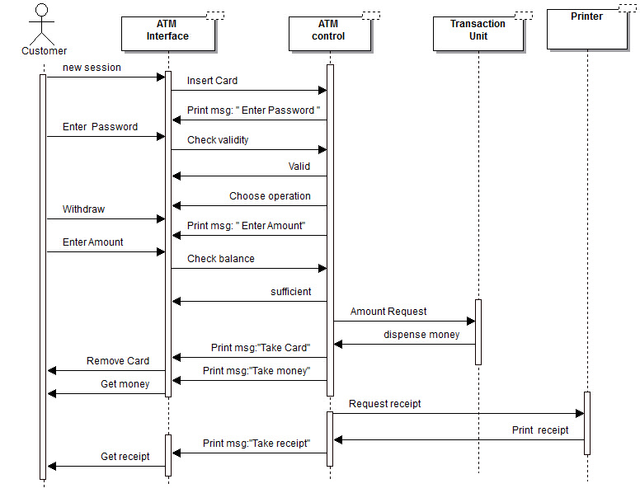

**TASKS**

Design the Sequence diagram for Courseware Management System case study application. The following use cases for the Courseware Management System were defined:

* View courses
* Manage topics for a course
* Manage course information
* View course calendar
* View tutors
* Manage tutor information
* Assign courses to tutors

Also show the collaboration diagram.